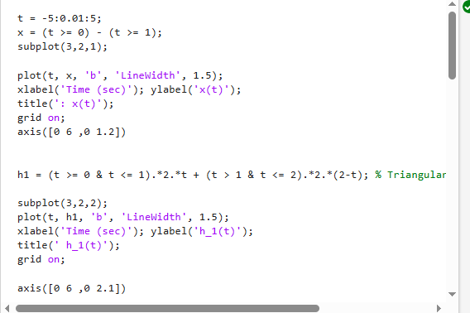
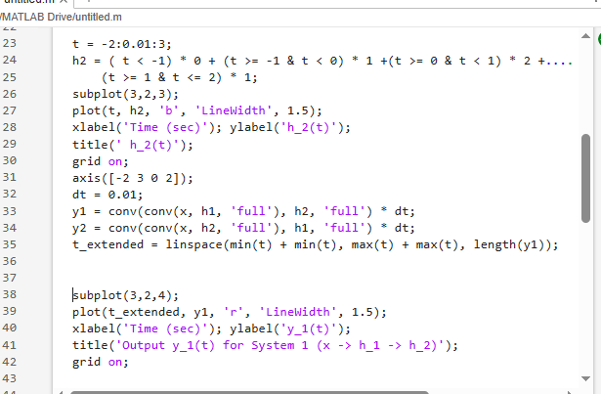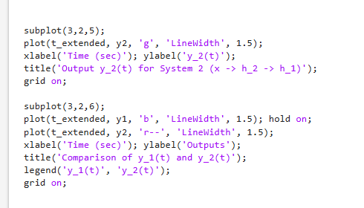
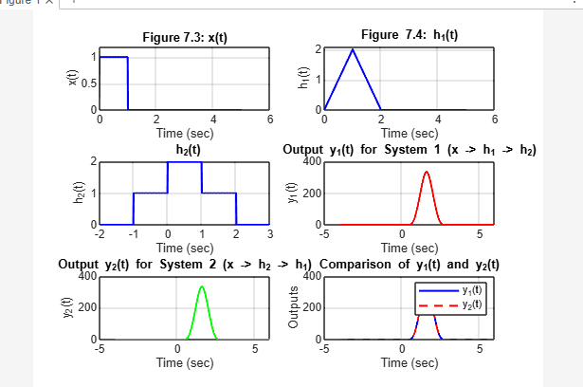
t = -5:0.01:5;
x = (t >= 0) - (t >= 1);
subplot(3,2,1);

plot(t, x, 'b', 'LineWidth', 1.5);
xlabel('Time (sec)'); ylabel('x(t)');
title(': x(t)');
grid on;
axis([0 6 ,0 1.2])

h1 = (t >= 0 & t <= 1).*2.*t + (t > 1 & t <= 2).*2.*(2-t); % Triangular function with amplitude 2

subplot(3,2,2);
plot(t, h1, 'b', 'LineWidth', 1.5);
xlabel('Time (sec)'); ylabel('h_1(t)');
title(' h_1(t)');
grid on;

axis([0 6 ,0 2.1])

t = -2:0.01:3;
h2 = ( t < -1) * 0 + (t >= -1 & t < 0) * 1 +(t >= 0 & t < 1) * 2 +....
(t >= 1 & t <= 2) * 1;
subplot(3,2,3);
plot(t, h2, 'b', 'LineWidth', 1.5);
xlabel('Time (sec)'); ylabel('h_2(t)');
title(' h_2(t)');
grid on;
axis([-2 3 0 2]);

dt = 0.01;

% Compute system response y1(t) for System 1 (x -> h1 -> h2)
y1 = conv(conv(x, h1, 'full'), h2, 'full') * dt;

% Compute system response y2(t) for System 2 (x -> h2 -> h1)
y2 = conv(conv(x, h2, 'full'), h1, 'full') * dt;

% Extend time vector for convolution results
t_extended = linspace(min(t) + min(t), max(t) + max(t), length(y1));

subplot(3,2,4);
plot(t_extended, y1, 'r', 'LineWidth', 1.5);
xlabel('Time (sec)'); ylabel('y_1(t)');
title('Output y_1(t) for System 1 (x -> h_1 -> h_2)');
grid on;

subplot(3,2,5);
plot(t_extended, y2, 'g', 'LineWidth', 1.5);
xlabel('Time (sec)'); ylabel('y_2(t)');
title('Output y_2(t) for System 2 (x -> h_2 -> h_1)');
grid on;

subplot(3,2,6);
plot(t_extended, y1, 'b', 'LineWidth', 1.5); hold on;
plot(t_extended, y2, 'r--', 'LineWidth', 1.5);
xlabel('Time (sec)'); ylabel('Outputs');
title('Comparison of y_1(t) and y_2(t)');
legend('y_1(t)', 'y_2(t)');
grid on;

